6th grade 3rd six weeks
6th Grade Mini Lesson Topics – Unit 6
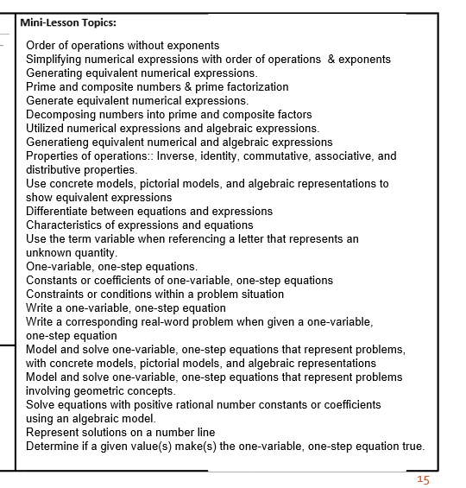

7th grade 3rd six weeks
7th Grade Mini Topics – Unit 6 *
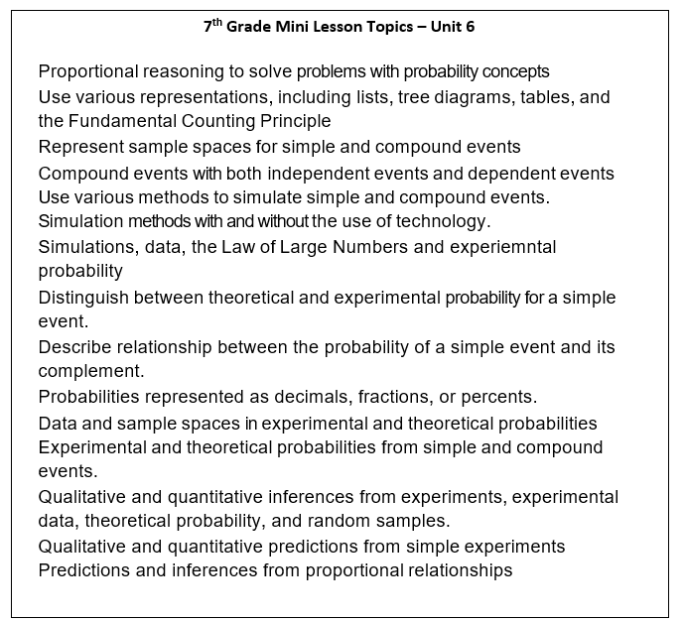

8th grade 3rd six weeks
